The Affects of Exercise on Blood Pressure
Written by: Thad Estes
Experiment by: Wilson Erwin and Thad Estes
4 December 2012

Abstract:
The purpose of this experiment was to see how a predetermined amount of exercise affected the systolic and diastolic blood pressure numbers. The exercise that one person had to perform was doing twenty-five push-ups. The person’s blood pressure was recorded before the exercise, right after the exercise, and five minutes after the exercise. The systolic number increased, and the diastolic number stayed the same or would slightly decrease when the exercise was performed and then decreased after 5 minutes.
Background:
The overall goal of this experiment was to determine how exercise would affect blood pressure. We tested to see if exercise would affect the systolic and diastolic blood pressure numbers. The blood pressure of one person in the group was recorded before the exercise. After twenty-five push-ups were performed, the blood pressure was taken again. After waiting five minutes, the blood pressure was taken again. According to livestrong.com, systolic blood pressure numbers should increase rapidly during exercise while the diastolic number should stay about the same or even slightly decrease. After continual exercise blood pressure should be lowered.
Hypothesis:
After doing twenty-five push-ups, systolic blood pressure numbers will increase, while diastolic numbers will stay about the same or they could even decrease a little. After five minutes, systolic blood pressure numbers will decrease and diastolic numbers will stay nearly the same or may even increase slightly.
Materials and Methods:
The materials that were used in this experiment were: a pencil/pen, a lab notebook, a computer, LoggerPro software, a blood pressure machine, and a person. First, the blood pressure was taken of a person at rest. The blood pressure was then recorded in the lab notebook. Afterwards, the person then did twenty-five push-ups. The blood pressure was then taken following the push-up and recorded into the lab notebook. After five minutes, the blood pressure was taken again and then recorded. Since there was two trials run, the steps needed to be repeated.
Results:
In the first graph, trial one’s blood pressure is shown as a vital sign. In the second graph, trial two’s blood pressure is shown as a vital sign. In the third graph, the oscillatory amplitude of trial one is shown. In the second graph, the oscillatory amplitude of trial two is shown. In the fourth graph, trial one’s blood pressure is shown as a vital sign. In the second graph, trial two’s blood pressure is shown as a vital sign.

Graph 1:
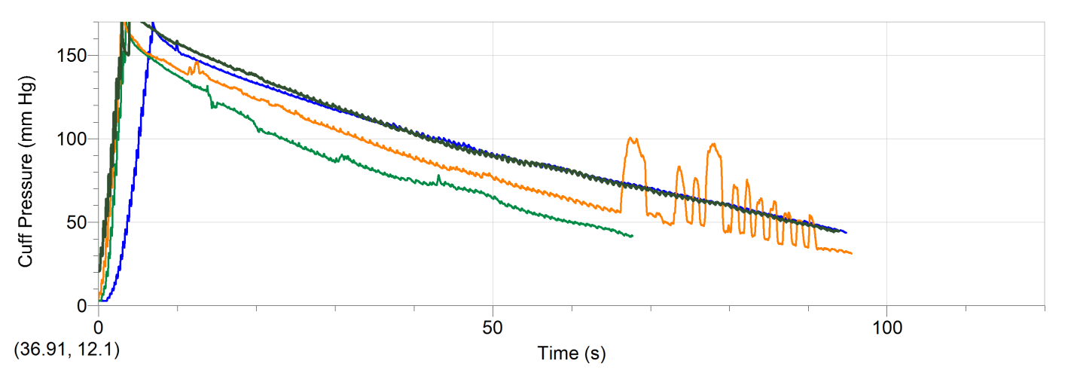

Graph 2:
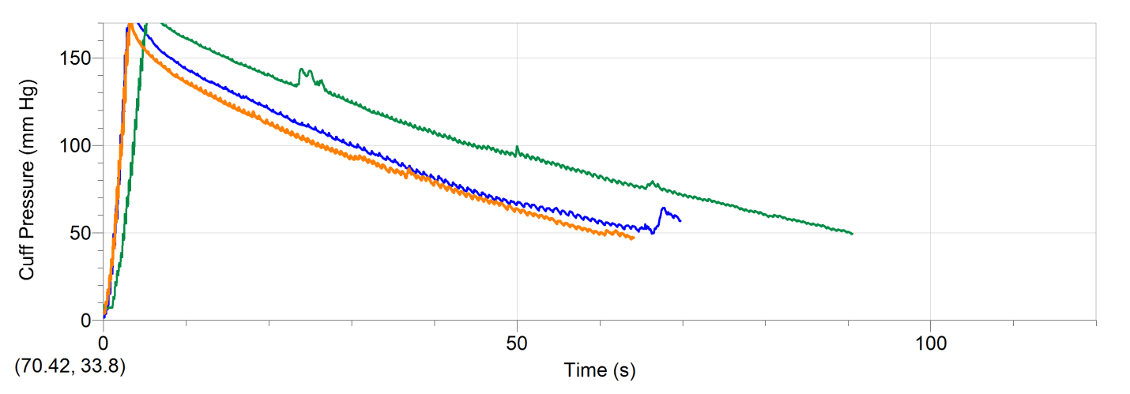
Graph 3:
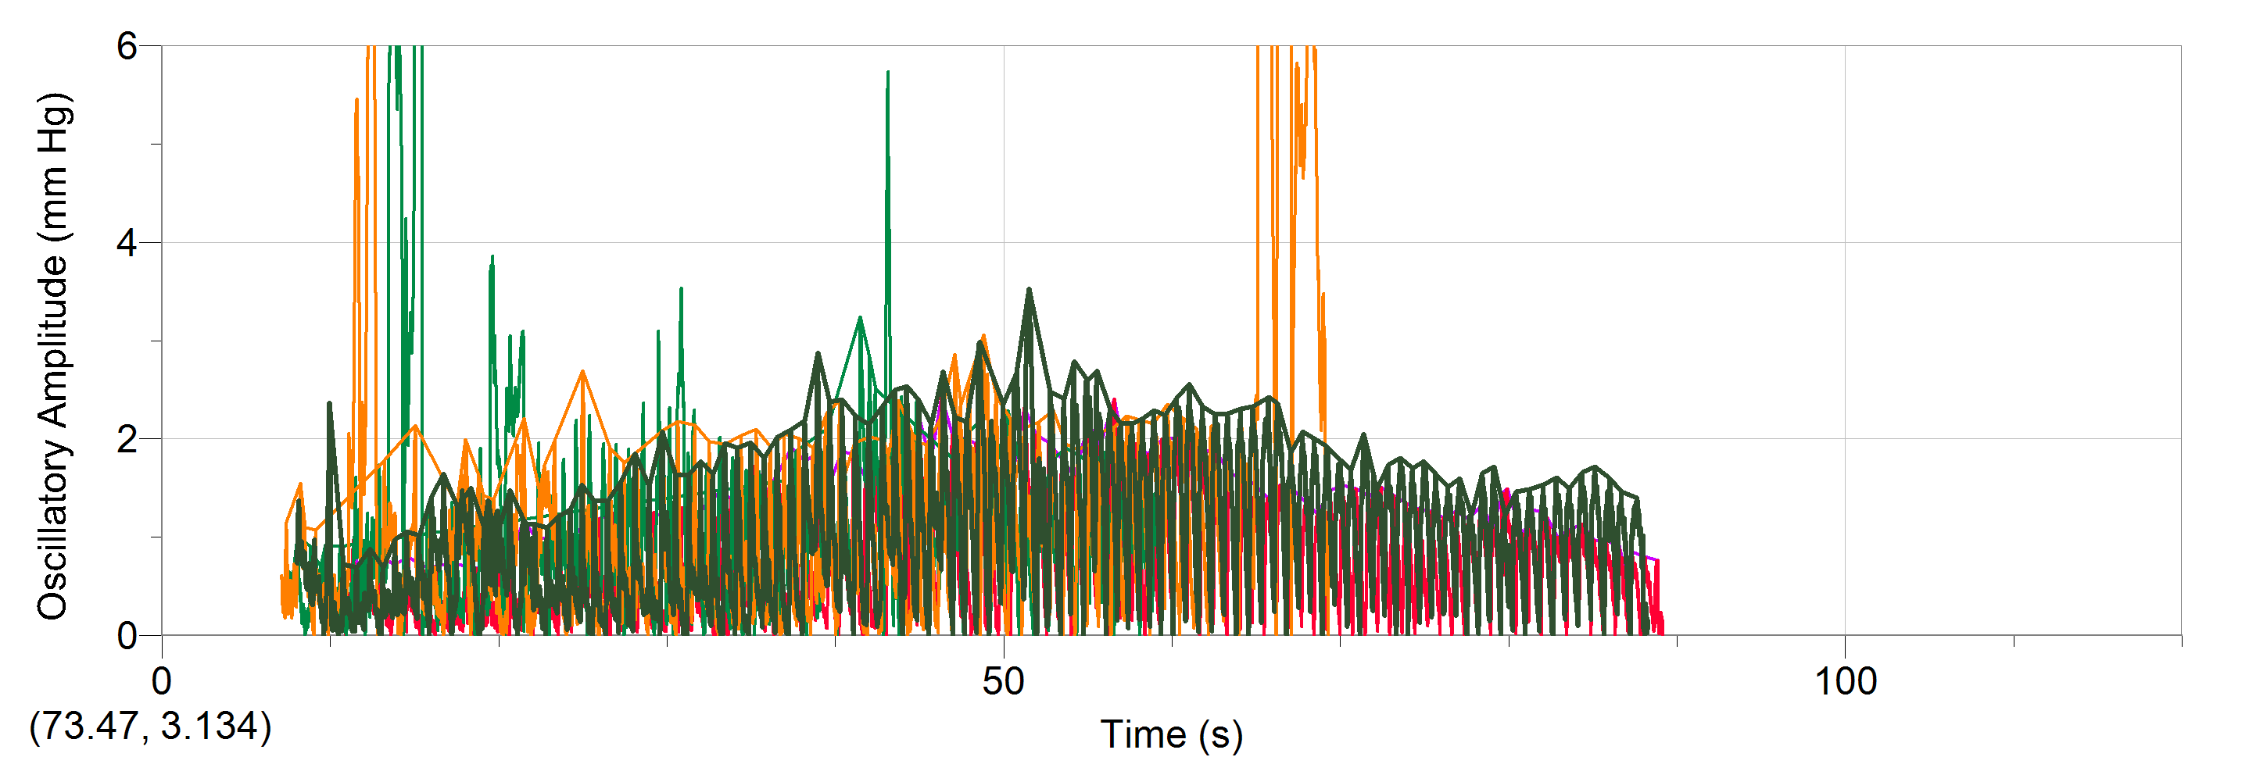
Graph 4:
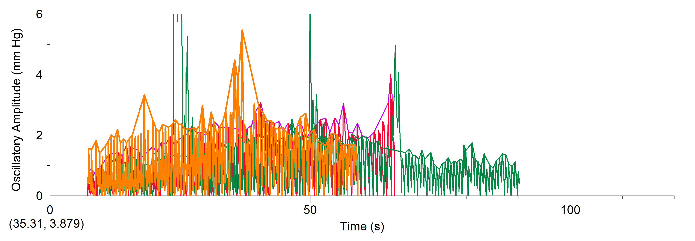

Discussion:
It is clear in both graphs one and two that the blood pressure readings taken before and five minutes after the exercise are significantly lower than that of the blood pressure reading taken right after the exercise. One possible error is that we did not stop cuff when it reached fifty mm Hg. An improvement so that the error would not occur would be to be more aware at looking at the cuff pressure. The information that Livestrong.com gave was supported by our results and I consider the information to be relevant.
Conclusion:
After performing twenty-five push-ups, systolic blood pressure numbers increased, and diastolic blood pressure numbers stayed the same, or slightly decreased. After waiting five minutes, systolic blood pressure numbers decreased, and diastolic blood pressure numbers slightly increased or stayed the same.
Citation:
Michelle, J. (2012) How Does Exercise Lower Blood Pressure? Livestrong.com. Retrieved from http://www.livestrong.com/article/27068-exercise-lower-blood-pressure/

